Lleswyl 2027 – Artist Application Form
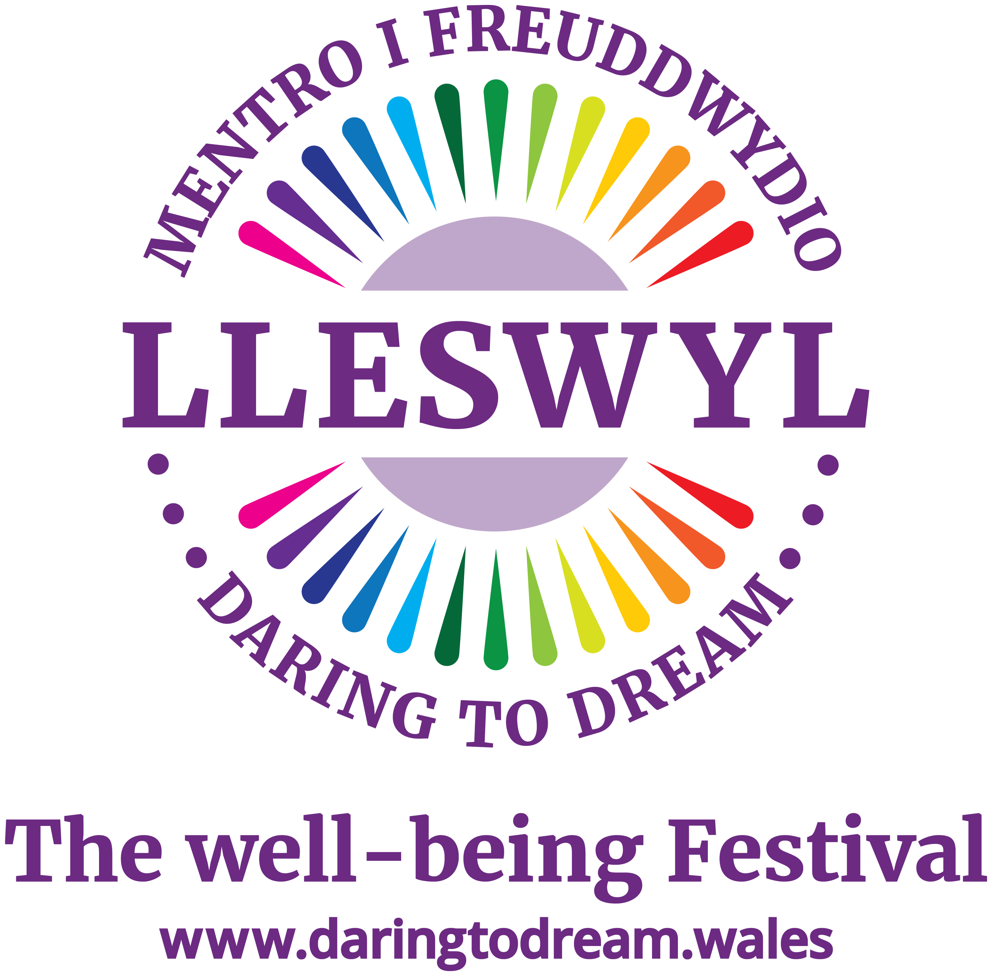
Organised by Daring to Dream (Registered Charity No. 1190590)
Lleswyl 2027 will be broadcast live on Friday 19 February 2027 from 7pm onwards from The Paget Rooms, Penarth.
Thank you for your interest in performing at Lleswyl 2027. Lleswyl is a unique, livestreamed 'festival-at-home' designed to bring the joy and emotional boost of quality and diverse music directly to individuals across Wales isolated by chronic illness, disability, or loneliness.
Please complete this application form to help our programming team understand your act, your technical setup, and how you align with our festival ethos.
Please note:
- Two acts will be selected to perform live on the night. Other selected acts will be ‘pre-recorded as live’ one weekend in November 2026 in Penarth.
- All selected acts will agree a contract with Daring to Dream relating to their performance in Lleswyl 2027 and related agreements and fees.
Section 1: Contact & Profile Details
• Artist / Band / Choir Name: ____________________________________________________
• Primary Contact Person: ____________________________________________________
• Email Address: ____________________________________________________
• Phone Number: ____________________________________________________
• Location (Town/City & County): ____________________________________________________
• Number of Performers on Stage: ____________________________________________________
• Artist Biography & Music Genre (Max 150 words):
____________________________________________________
Section 2: Ethos Alignment & Performance Style
Lleswyl focuses on delivering an uplifting and joyous experience. It is a powerful mix of fabulous music and conversations highlighting the role of emotional health in living well with illness.
- Briefly describe how your set/repertoire fits this atmosphere:
____________________________________________________
2. As a hybrid digital festival, engaging with a remote camera audience is crucial. Do you have experience projecting energy to an online or broadcast audience?
[ ] Yes [ ] No
Comments: __________________________________________
3. Do you perform any songs in the Welsh language, or are you able to offer a bilingual introduction?
[ ] Yes, fully Welsh [ ] Yes, bilingual elements [ ] English only
Section 3: Media & Performance Links
Please provide links to high-quality videos of live performances or audio tracks (e.g., YouTube, Vimeo, SoundCloud, Spotify):
• Live Performance Video Link 1: ____________________________________________________
• Live Performance Video Link 2: ____________________________________________________
• Audio / Website / Social Media Link: ____________________________________________________
Section 4: Technical & Logistics
• Preferred Performance Setup (e.g., Full Live Band, Acoustic, Choir with Backing Tracks): ____________________________________________________
• Key Instruments Used: ____________________________________________________
Do you have a standard technical rider/stage plan available if requested?
[ ] Yes [ ] No
Section 5: Your fee
• Your fee: ______________________________
• Do you charge VAT: [ ] Yes [ ] No
Section 6: Declaration & Support
Lleswyl is organised by the charity Daring to Dream to raise vital awareness and provide live-streamed and ‘on demand’ entertainment free-of-charge for chronically ill adults. The broadcast night studio audience will purchase tickets for their Lleswyl experience.
By submitting this application, you acknowledge the charitable nature of the festival and express a willingness to work collaboratively with our team to support this cause.
• Signature of Applicant: ____________________________________________________
• Date: ____________________________________________________

