#SUPPORTING #CHRONICALLYILL #DISABLED

FEATURING:
#INCLUSIVE #ACCESSIBLE #FREE

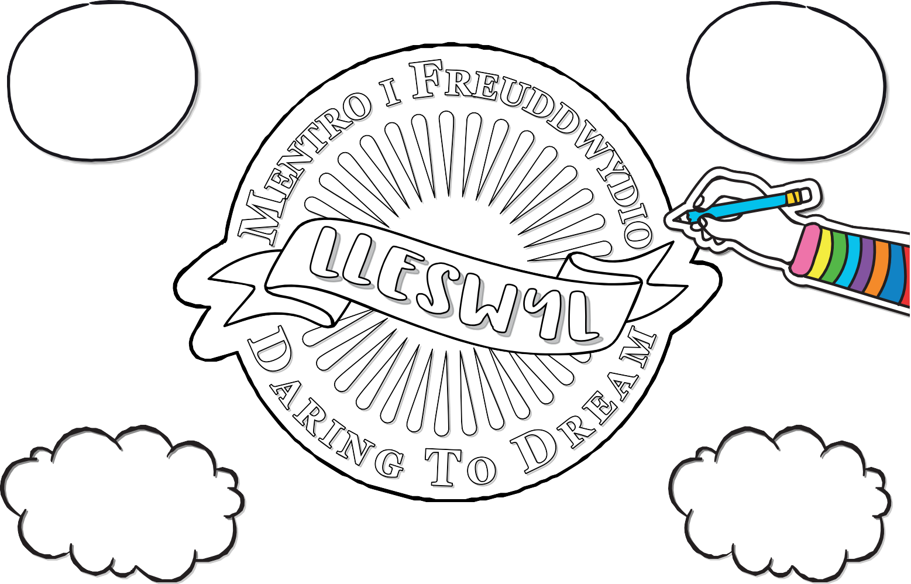AFRO CLUSTER CALAN
DOCTOR AND THE
MEDICS ROOT DOCTORS
PHILANTHROPY JAZZ
IFY IWOBI LIV E BAND
THE GENTLE GOOD
ROYAL WELSH COLLEGE
©scarlet design international ltd 2021
OF MUSIC AND DRAMA AMSER JAZZ TIME

REGISTER FOR YOUR FREE TICKETS AT HTTPS://LLESWYL.EVENTBRITE.CO.UK

